Use Dashboard Nodes For Creating UI(Web App)

|  |  |
| --- | --- |
| Team ID | PNT2022TMID12755 |
| Project Name | Signs with smart connectivity for better road safety |

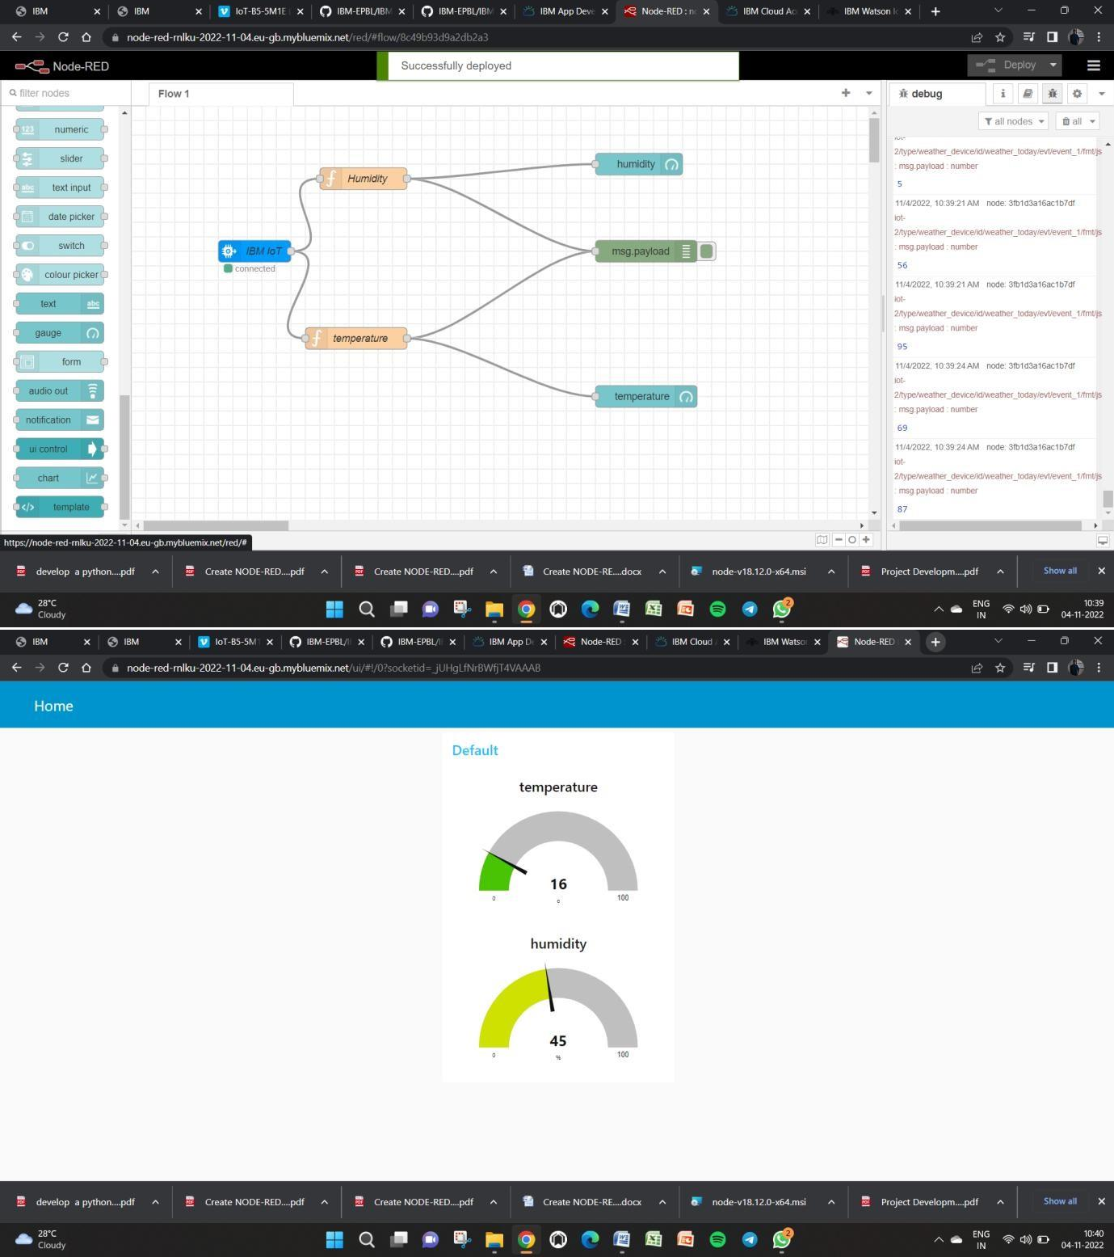

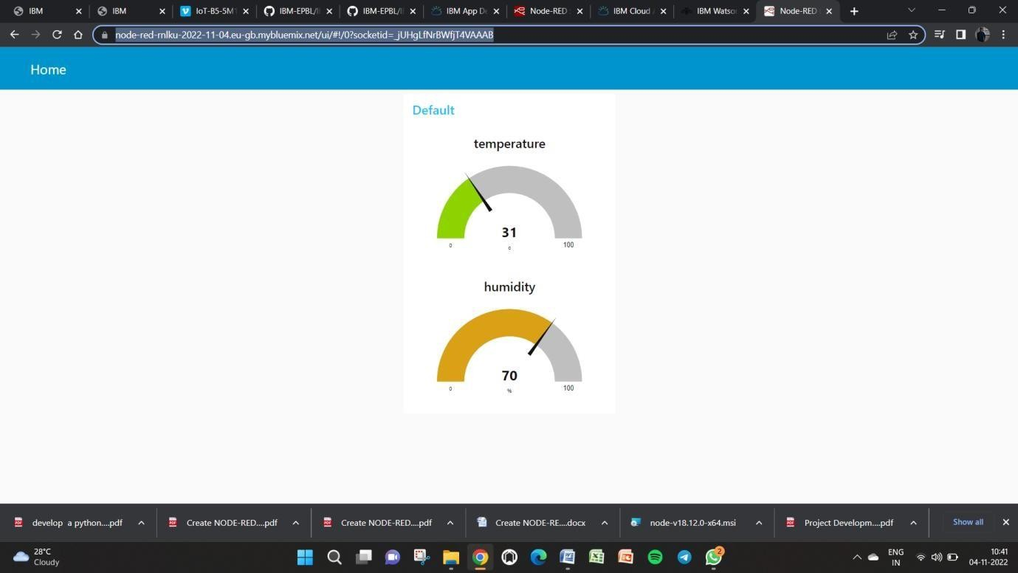

url for device:

https://node-red-rnlku-2022-11-04.eu- gb.mybluemix.net/ui/#!/0?socketid=_jUHgLfNrBWfjT4VAAAB